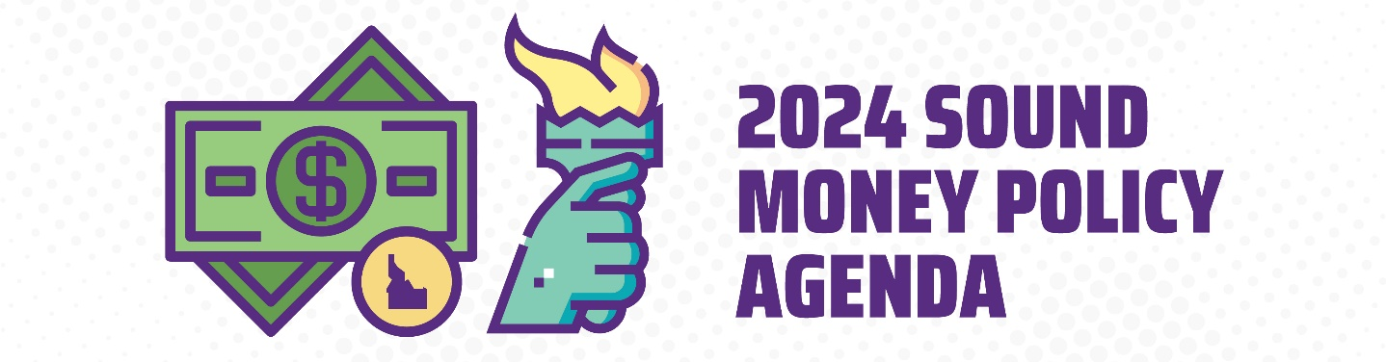

State Financial Sovereignty Act
SECTION 1. Amending the State Universal Commercial Code.
- “Money” means a medium of exchange currently authorized or adopted by a domestic for foreign government. The term includes a monetary unit of account established by an intergovernmental organization or by agreement between two (2) or more countries. This term does not include a central bank digital currency as defined in section [INSERT].
SECTION 2. Central bank digital currency payments prohibited.
- For the purposes of this section, “central bank digital currency” means a digital currency, a digital medium of exchange, or a digital monetary unit of account issued by the United States federal reserve system or a federal agency which is made directly available to a consumer by such entities. The term includes a digital currency, a digital medium of exchange, or a digital monetary unit of account issued by the United States federal reserve system, a federal agency, or which is processed or validated directly by such entities. A central bank digital currency does not mean a digital asset which is issued by a private entity which is backed by legal tender or government treasuries.
- The state, a county, a city, or any local political subdivision thereof shall not:
  - Accept, transact, trade, or exchange central bank digital currency as a means of payment;
  - Participate in any test or central bank digital currency by any federal reserve branch;
  - Establish any program that utilized central bank digital currency;
  - Participate in any federal program that is contingent on the use of a central bank digital currency; or
  - Accept any federal grant or award that is contingent on the use of a central bank digital currency.
- The state shall withdraw from any federal program that requires the use of central bank digital currency. This section shall not apply to any program where the state is granted a waiver that voids the requirement to use a central bank digital currency.
- Any intentional violation of the provisions of this chapter by a public officer or public employee shall be considered a misuse of public moneys pursuant to section [INSERT].

